Read me

Data Got Talent 2024

The proposed final cleaned data consists of 2 files:

* [Vòng 1-Cleaned Data.xlsx](https://docs.google.com/spreadsheets/d/1j3uL-4rAsZ6jNF_Vs9VtJ8qkHDbPer0-/edit?usp=drive_link&ouid=102890278591603874251&rtpof=true&sd=true)
* [Danang_street_name.xlsx](https://docs.google.com/spreadsheets/d/1zgsHssgItWtYqYRq-iFFoQwLRHNGEgEX/edit?usp=drive_link&ouid=102890278591603874251&rtpof=true&sd=true) (information scrapped from <https://congdulieu.vn/dulieuchitiet/1037328> and <https://diaocthinhvuong.vn/danh-sach-don-vi-hanh-chinh-thanh-pho-da-nang/>)

And the coding files included of:

* [D5TA.ipynb](https://drive.google.com/file/d/1Rb8NedBww_prjL_QoCctPfCYL3cm0brq/view?usp=drive_link)
* [RFM.sql](https://drive.google.com/file/d/1l5MLU9QB6WX6YrvnfLYLxiNIc1qhVnNB/view?usp=drive_link)

About the cleaned data

* Data model

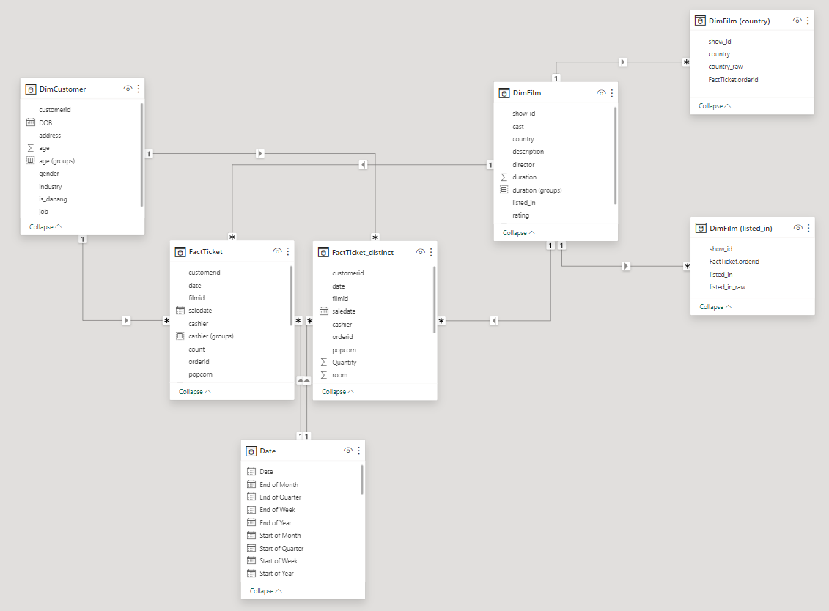

* Code DAX of Date Table

CODE DAX DATE TABLE

Calendar =

var _fromYear=2019

var _toYear=2019

var _startOfFiscalYear=4

//**************

var _today=TODAY()

return

ADDCOLUMNS(

CALENDAR(

DATE(_fromYear,1,1),

DATE(_toYear,12,31)

),

"Year",YEAR([Date]),

"Start of Year",DATE( YEAR([Date]),1,1),

"End of Year",DATE( YEAR([Date]),12,31),

"Month",MONTH([Date]),

"Start of Month",DATE( YEAR([Date]), MONTH([Date]), 1),

"End of Month",EOMONTH([Date],0),

"Days in Month",DATEDIFF(DATE( YEAR([Date]), MONTH([Date]), 1),EOMONTH([Date],0),DAY)+1,

"Year Month Number",INT(FORMAT([Date],"YYYYMM")),

"Year Month Name",FORMAT([Date],"YYYY-MMM"),

"Day",DAY([Date]),

"Day Name",FORMAT([Date],"DDDD"),

"Day Name Short",FORMAT([Date],"DDD"),

"Day of Week",WEEKDAY([Date]),

"Day of Year",DATEDIFF(DATE( YEAR([Date]), 1, 1),[Date],DAY)+1,

"Month Name",FORMAT([Date],"MMMM"),

"Month Name Short",FORMAT([Date],"MMM"),

"Quarter",QUARTER([Date]),

"Quarter Name","Q"&FORMAT([Date],"Q"),

"Year Quarter Number",INT(FORMAT([Date],"YYYYQ")),

"Year Quarter Name",FORMAT([Date],"YYYY")&" Q"&FORMAT([Date],"Q"),

"Start of Quarter",DATE( YEAR([Date]), (QUARTER([Date])*3)-2, 1),

"End of Quarter",EOMONTH(DATE( YEAR([Date]), QUARTER([Date])*3, 1),0),

"Week of Year",WEEKNUM([Date]),

"Start of Week", [Date]-WEEKDAY([Date])+1,

"End of Week",[Date]+7-WEEKDAY([Date]),

"Fiscal Year",if(_startOfFiscalYear=1,YEAR([Date]),YEAR([Date])+ QUOTIENT(MONTH([Date])+ (13-_startOfFiscalYear),13)),

"Fiscal Quarter",QUARTER( DATE( YEAR([Date]),MOD( MONTH([Date])+ (13-_startOfFiscalYear) -1 ,12) +1,1) ),

"Fiscal Month",MOD( MONTH([Date])+ (13-_startOfFiscalYear) -1 ,12) +1,

"Day Offset",DATEDIFF(_today,[Date],DAY),

"Month Offset",DATEDIFF(_today,[Date],MONTH),

"Quarter Offset",DATEDIFF(_today,[Date],QUARTER),

"Year Offset",DATEDIFF(_today,[Date],YEAR)

)